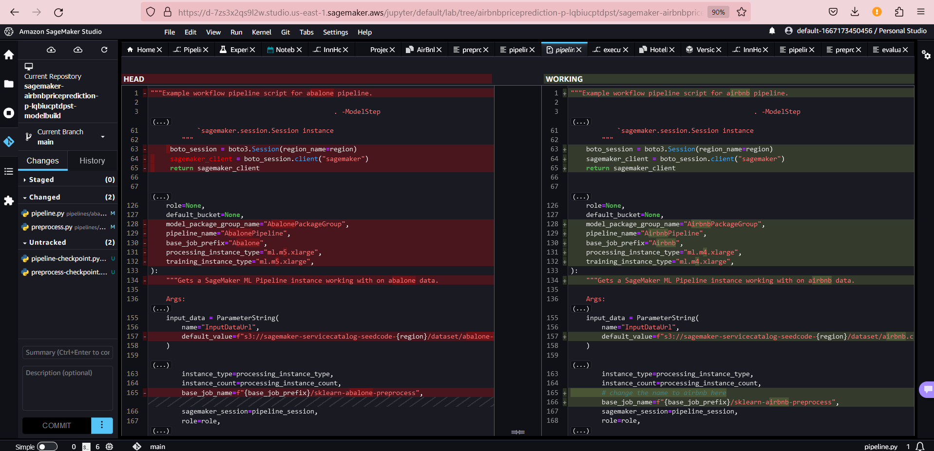

At this stage, my model build pipeline is completed, with train rmse as 0.48 and validation rmse as 0.4845 which is a good model without overfitting. While pre-processing I had converted price into log(price) so to interpret rmse in terms of $ price, I take exp(0.48) which is ~1.6$

Now, I’ve to go to the model groups under project, select this version 2 of Airbnb pipeline, and approve the model.

Once I’ve approved the build model, model deployment pipeline will be executed. This can be verified in the code commit-> pipeline

Once deploy pipeline is executed,and all the steps including testing are completed in this pipeline successfully, it will wait for a manual approval. You’ll find this in Code Pipelines-> model deploy pipeline

Approve I manually, after checking performance of pipeline. Once you complete this step, you’ll find below ‘updating’ status in the endpoints section of the model.

Finally, once the deploy pipeline is completed after manual approval, we can verify its status in code commit as shown below:

